

**ASIA PACIFIC COLLEGE**

**School of Computer Science and Information Technology**

**FoodTrip Search Engine**

**Project Members:**

Tan, Jimmy

Zuñiga, Rouzandra

Marquez, Iñigo

Juarez, Jason

**Instructor Name:**

Mr. Manuel Sebastian Sanchez



Project Documentation Submitted

To the Faculty of School of

Computer Science and Information Technology

Of

Asia Pacific College

In Partial Fulfillment of the Requirements for the subject

Applied Projects 2 or Software Development

**Members**

Jimmy Tan

Rouzandra Zuñiga

Iñigo Marquez

Jason Juarez

**Professor**

Prof. Manuel Sebastian Sanchez

Table of Contents

Page No.

**I. Narrative**……………………………………………………………………………............................1

**A. Executive Summary**.…………………………………………………………………………...........1

**B. Introduction**…...………………………………………………………………………………...........1

1. Client Profile………………………………………………………………………………..............2

2. Project Organization……………………………………………………………………................2

a. Project Team…………………………………………………………………….....….........2

b. Project Professor…………………………………………………………………...............2

c. Project Adviser……………………………………………………………………...............2

3. Client’s Mission and Objectives…………………………………………………………..............3

4. Project Objectives………………………………………………………………………................3

5. Purpose of the Project……..……………………………………………………………...............3

6. Rationale of the Project………….……..………………………………………………................4

a. The Current Process Flow…………………………………………………………............4

b. User Information Needs………………………………………………………………........5

**C. Systems Features and Functions**…………………………………………………………...........5

1. Software Environment………………………………………………………………….................5

a. Programming Languages…………….……………………………………………….........5

b.Specific Software……………………………………………………………………............5c. Operating System……………………………………………………………...….............................5

d. Other Software……………………………………………………………………...............5

2. Hardware Environment……………………………………………………………….. ……..............6

3. Networking and Security……………………………………………………………………..............6

a. Security……………………………………………………………………..........................6

b. Server………………………………………………………………………………..............6

**II. Application System Modules**………………………………………………………………..........7

**A. Data Flow Diagrams**…………………………………………………………………………..........11

1. Context Level Data Flow Diagram………………………………………………………............11

2. Level 0 Data Flow Diagram……..……………………………………………………….............12

**B. UML Diagrams** ………………………………………………………….......................................13

**C. Entity – Relationship Diagram**………………………………………………….........................19

**D. Data Dictionary**……………………………………………………………………..........…………20

**E. Screenshots**……………………………………………………………………………..............….21

**F. Lessons Learned**……………………………………………………………………...............…...24

**III. Appendices**……………………………………………………………………………..............…..24

**IV. Curriculum Vitae**...................................................................................................................25

ii

1. **Narrative**

Being well known, Filipinos are excited to try new food and taste different cuisine. They even tend to explore and discover different places and different cultures starting from their hometowns and cities, to satisfy themselves in their desires of eating different food. In Makati, food is a leisure to different kinds of citizens, and the well-stabilized people are the majority of the seekers of this kind of leisure. The drive to try out every dish with these restaurants is inevitable since majority of the people are curious about new restaurant to try out. Hence, people love to find new restaurants just to satisfy one’s self. Lack of information and location in directions are becoming a problem since it gives inconvenience to diners/customers. That is why the project “Food Trip Search Engine” seems the most viable solution in solving the problem to try out and visit restaurants around Makati.

1. **Executive Summary**

The project “Food Trip Search Engine” is a mobile application that displays complete specific restaurants regarding its category, description, images and prices of dishes, and menus. This also shows how search results of restaurants are displayed. This application is developed to implement and market restaurants by showing details and information about the restaurant. The most important part is to show its restaurant location and to help make users to access restaurant.

**B.**     **Introduction**

Food Trip Restaurant Search Engine is a mobile application wherein a user can easily discover and explore high-class restaurants around Makati with each different type of cuisines of different cultures. Whenever users choose a restaurant they wish to visit, users can view their detailed information, they can call directly to the restaurant, visit website and email the restaurant for bookings and reservation. The “FoodTrip Search Engine” application is a guide to good food and good restaurant to find, the admin can recommend through the featured restaurant where users can find great place to eat.

1

1. **Client Profile**

**Personal Information**

|  |  |  |  |  |  |  |  |  |  |  |  |  |  |  |  |  |  |
| --- | --- | --- | --- | --- | --- | --- | --- | --- | --- | --- | --- | --- | --- | --- | --- | --- | --- |
| Last Name: | | FerrerFerrer | | | | | | First: | | Gef GailGef Gail | | | | | Middle: | | DD |
| Maiden Name: | | | | GefGef | | | | | | | | Date of Application: | | | | April 10, 2016April 10,2016 | |
| Date of Birth: | | | | | | June 18, 1989June 18, 1989 | | | Place of Birth: | | | | CalgaryCalgary | | | | |
| Address: | Imus Cavite City | | | | | | | | | | | | | | | | |
| Phone Number: | | | | | | | N/AN/A | | | | Work Number: | | | 80178798017879 | | | |
| Cell Number: | | | 0977826738209778267382 | | | | | | | | Email Address: | | | gefyu@gmail.com[gefyu@gmail.com](mailto:gefyu@gmail.com) | | | |
| Occupation: | | | | | General Manager | | | | | | | | | | | | |

**Company Information**

|  |  |  |  |  |
| --- | --- | --- | --- | --- |
| Company Name: | Abigle CafeAbigle Cafe | | Position Title: | General ManagerGeneral Manager |
| Company Address: | | 2nd & 3rd floor RCT Building, 252 Urban Ave, 252 Urban Avenue, Pio Del Pilar, Makati, 1230 Metro Manila 2nd & 3rd floor RCT Building, 252 Urban Ave, 252 Urban Avenue, Pio Del Pilar, Makati, 1230 Metro Manila | | |

**2.**      **Project Organization**

**a.**      **Project Team**

|  |  |  |
| --- | --- | --- |
| Name | Position | Email |
| Jimmy Tan | Project Leader | [iftan@student.apc.edu.ph](mailto:iftan@student.apc.edu.ph) |
| Rouzandra Zuniga | Project Developer and Designer | [rbzuniga@student.apc.edu.ph](mailto:rbzuniga@student.apc.edu.ph) |
| Jason E. Juarez | Project Developer | [jejuarez@student.apc.edu.ph](mailto:jejuarez@student.apc.edu.ph) |
| Iñigo Marquez | Project Web Developer | [iumarquez@student.apc.edu.ph](mailto:iumarquez@student.apc.edu.ph) |

**b.**     **Project Professor**

|  |  |  |
| --- | --- | --- |
| Name | Position | Email |
| Mr. Manuel “Sean” Sebastian Sanchez | Professor | [manuels@apc.edu.ph](mailto:manuels@apc.edu.ph) |

**c.**      **Project Adviser(s)**

|  |  |  |
| --- | --- | --- |
| Name | Position | Email |
| Mr. Ernesto “Boogie” Boydon | Project Advisor |  |
|  |  |  |

2

1. **Client’s Mission and Objectives**

   FerrerTo ensure that each guest receives prompt, professional, friendly and courteous service. To maintain a clean, comfortable and well maintained premises for our guests and staff. We are committed to using the finest ingredients in our recipes. We provide the following:

* To provide a good place for business meetings
* To provide a good place for group parties,
* To provide a good place for hardcore gaming experience with high-end equipment at “Razer Gaming Internet Café” To ensure that each guest receives prompt, professional, friendly and courteous service. To maintain a clean, comfortable and well maintained premises for our guests and staff. We are Razer G for Hardcore Gamers.

**4.**      **Project Objectives**

**General Objectives:**

The general objective of this project is to provide diners/users convenience in accessing, and exploring locations and information about high class restaurants around Makati.

**Specific Objectives:**

• To provide a hassle-free restaurant search around Metro Manila.

• To find desired restaurants a diner/user who wants to visit.

• To show updated menus and promotions offered by restaurants.

**5.**      **Purpose of the Project**

The purpose of this document is to present a detailed description of the Food Trip Search Engine Mobile App, to explain the purpose and features of the system, the interfaces of the system, what the system does, the constraints under which it must operate. This document is intended for both stakeholders and developers of the system.

3

**6.**      **Rationale of the Project**

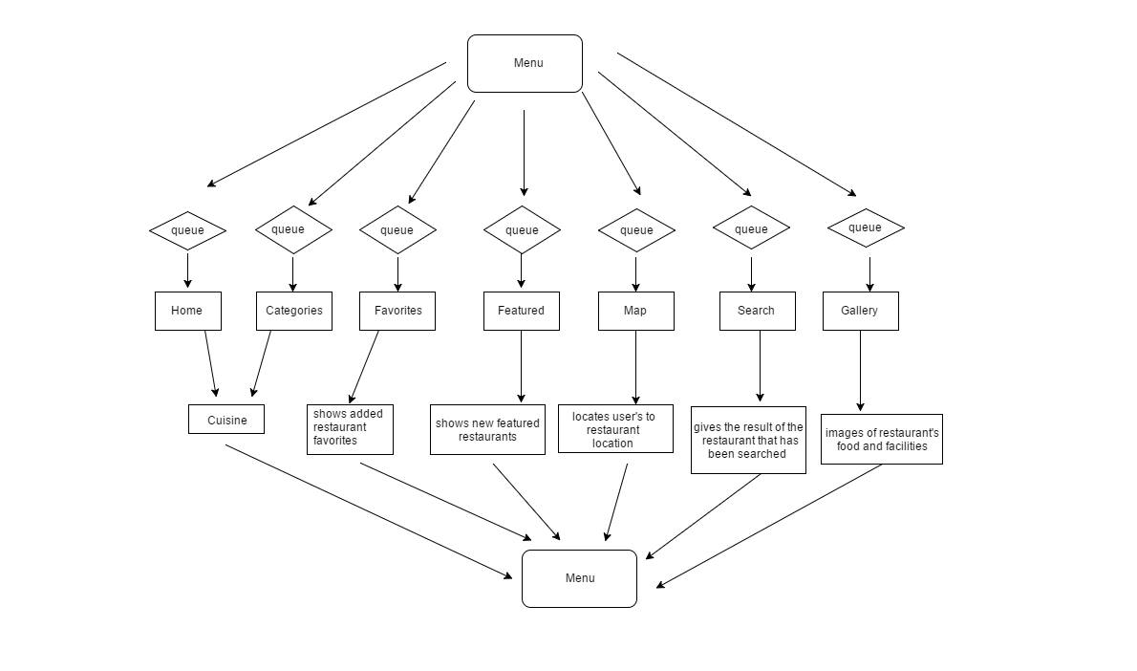**a.**      **The Current Process Flow**

**\* The menu elaborates and provides several processes in features that possibly runs simultaneously.**

**4**

**b. User Information Needs**

The Mobile Application provides all the information that users need to know starting from restaurant details (address, food rating, price range, working hours and amenities), restaurant’s gallery, to a map to provide users the exact location of the restaurants.

**C.**     **Systems Features and Functions**

**1.**       **Software Environment**

**a.**      **Programming Languages**

HTML 5, CSS3, java script, java, PHP, mobile framework

**b.**     **Specific Software**

Android Studio IDE

Android SDK tools

Android 4.4(Kitkat) platform

Android 4.4 emulator

Notepad++

Adobe Photoshop

Eclipse

Adobe Dreamweaver

**c.**    **Operating System**

Android 6.0(Marshmallow) platform

**d.**    **Other Software**

Sublime 2

5

1. **Hardware Environment**

The focus of this project is to apply the use of android phones and the internet for the user for convenience of knowing better information about different cuisines and restaurants around Makati.

**Minimum Requirements:**

1.3 GHz processor

RAM: At least 1 GB RAM

OS: Android 4.4 API 19 (Kitkat)

Free Disk Space:4 GB

Internet connection: mobile data or Wifi connection (3G,4G, LTE, HSDPA)

**3.**      **Networking and Security**

**a.**      **Security**

SSL (Secure Socket Layer)

**b.**     **Server**

**LOCAL SERVER** SQL (Structured Query Language)

6

**4.**      **Application System Modules**

**Getting Started**__________________________________________________ _

  **Tap this button on your Phone to start the Food Trip app.**

The language used for buttons and menus in the Food Trip app is the same as the language you selected in the Phone settings.

**______________________________________________________________________**

1. 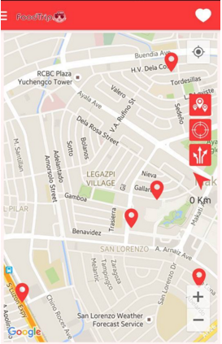**GPS Reception_______________________________________________ ____**

When you start the Food Trip app, it may need a few minutes to find your GPS position to show your current location on the map

To make sure you have good GPS reception, you should use your device outdoors. Large objects such as tall buildings can sometimes interfere with reception.

______________________________________________________________________

**Important: Food Trip app cannot give you route instructions until it has GPS reception. If your device has no GPS reception, Food Trip app uses positioning information from WiFi networks or mobile data. This information is used** **for route planning and to determine your approximate location.**

______________________________________________________________________

7

1. **Home**___________________________________________________________

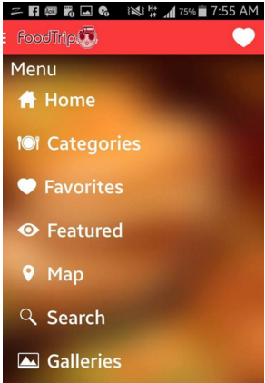

After GPS Location is activated, the user may now start with the app

**This is the Homepage of the mobile app:**

* + Home
  + Categories
  + Favorites
  + Featured
  + Map
  + Search
  + Galleries

1. **Categories**______________________________________________________________________

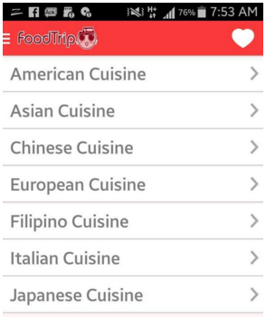

Under Categories, the user may see the different Cuisine.

After the user chooses one (1) restaurant under specific category, the user may see the details, map and gallery of the restaurant.

8

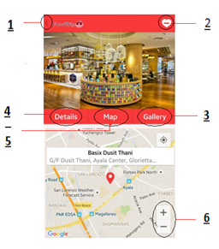

1. Back to previous menu.
2. Mark to one of the user favorite.
3. View pictures of the selected restaurant.
4. View restaurant menu, price, contact number, address, official website, email.
5. View restaurant location.
6. To zoom in and zoom out map.

9

1. **Search__________________________________________________________**

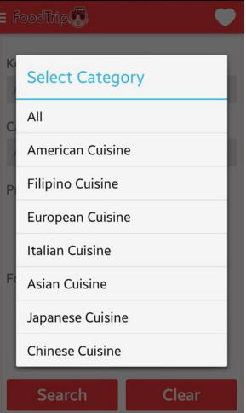

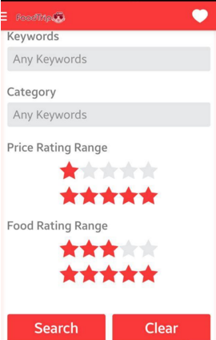

**The user may enter restaurant name in search menu bar.**

**The user may select category to find the restaurant easily.**

**After the user input the correct information (keyword), they may tap the search button or if they want to cancel the process, they may tap clear button**

1. **Galleries_________________________________________________________**

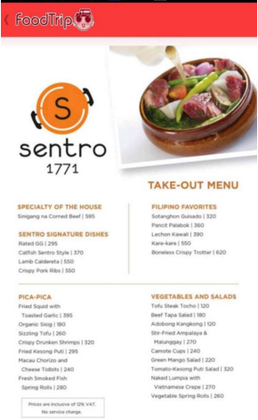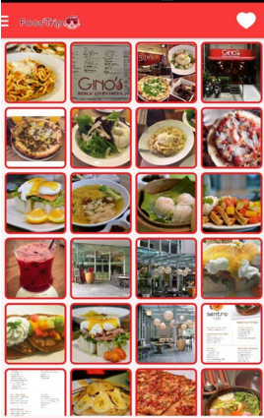

**The user may view Galleries tab for them to have an idea what food of the certain restaurant offers**

**Aside from food, galleries also have sample pictures of some restaurant beautiful places.**

10

**II.**              **System Diagrams and Screenshots**

**A.**        **Data Flow Diagrams**

1. **Context Level Data Flow Diagram**

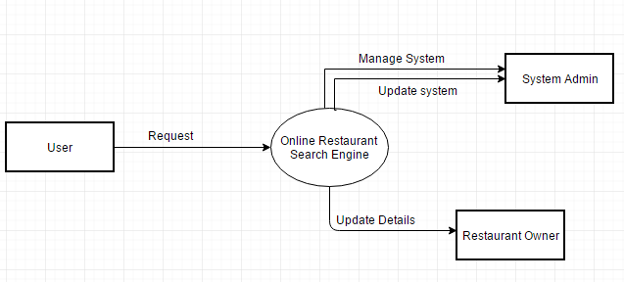

11

1. **Level 0 Data Flow Diagram**

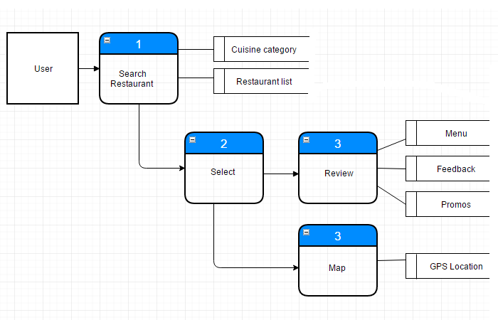

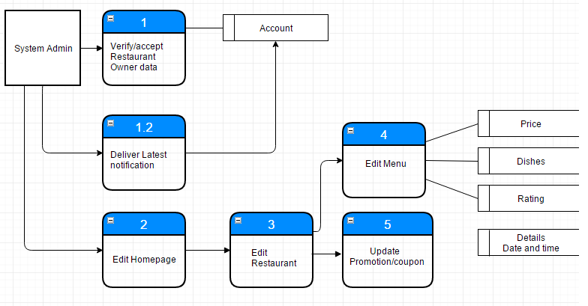

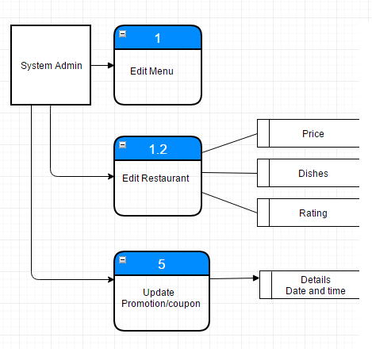

12

**B.**        **UML Diagrams**

**Activity Diagram**

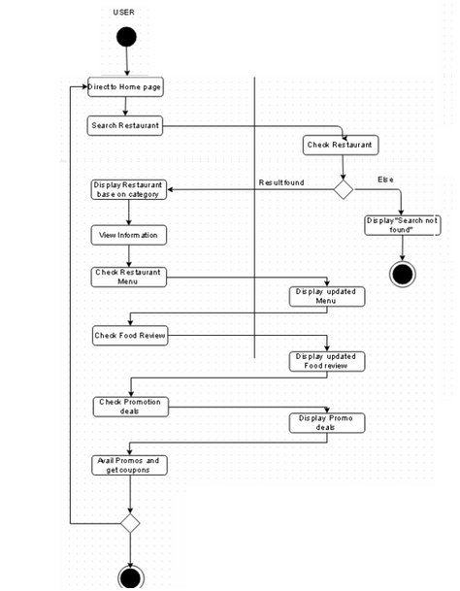

**Displays the process on how the features serve their roles in the application.**

13

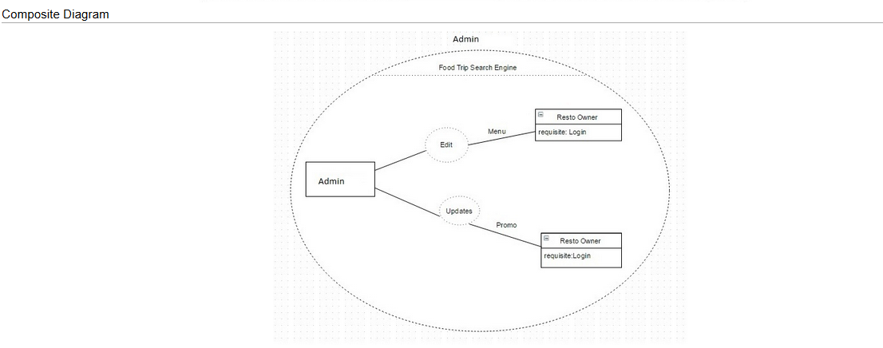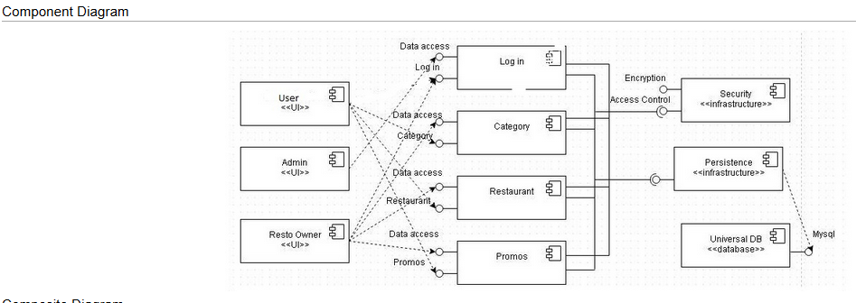

14

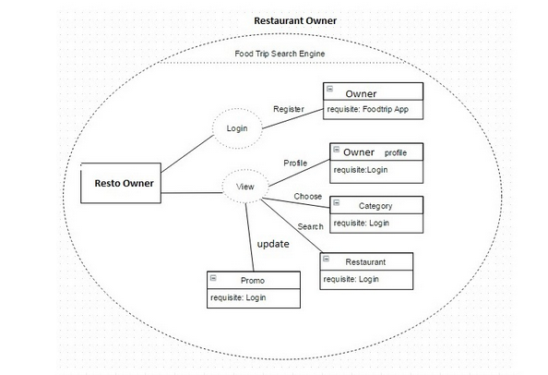

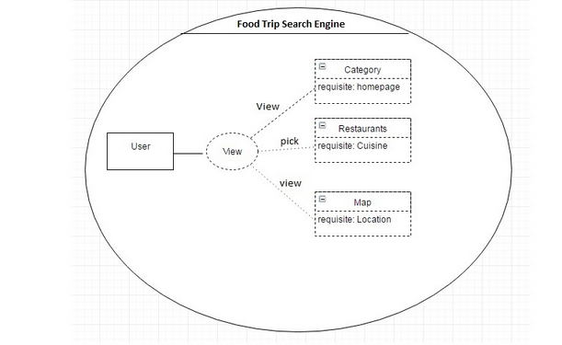

15

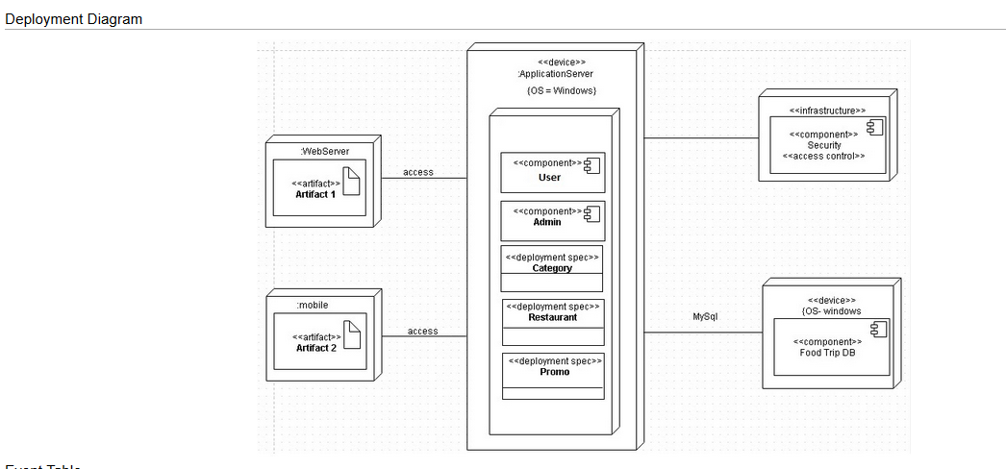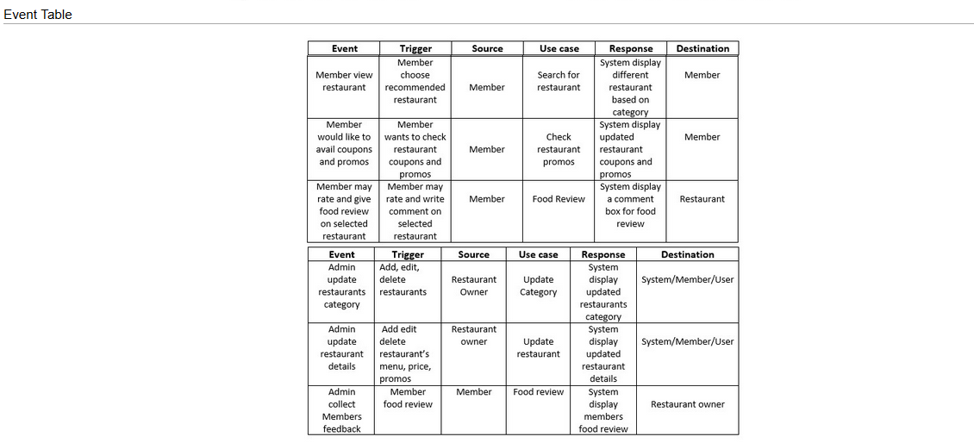16

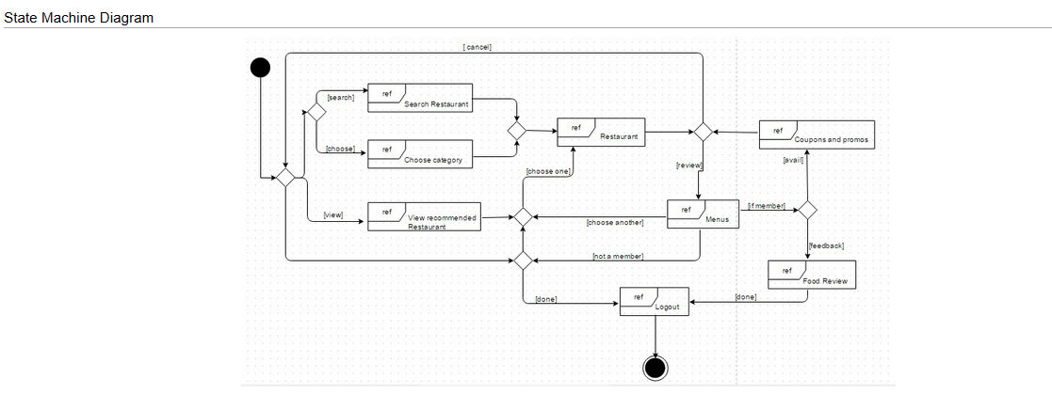

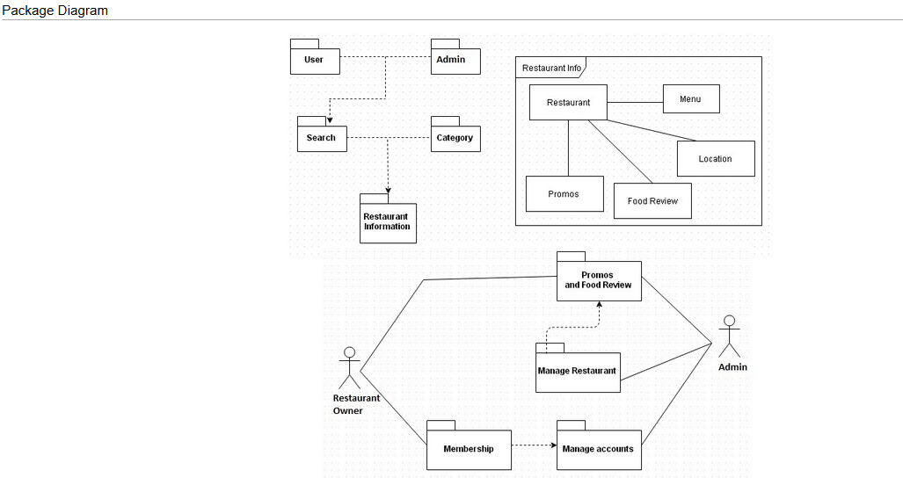17

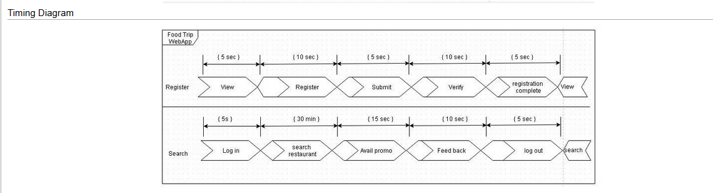

Use Case Diagram

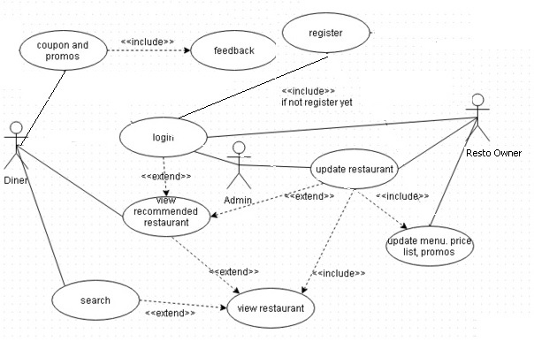

18

**C.**        **Entity – Relationship Diagram**

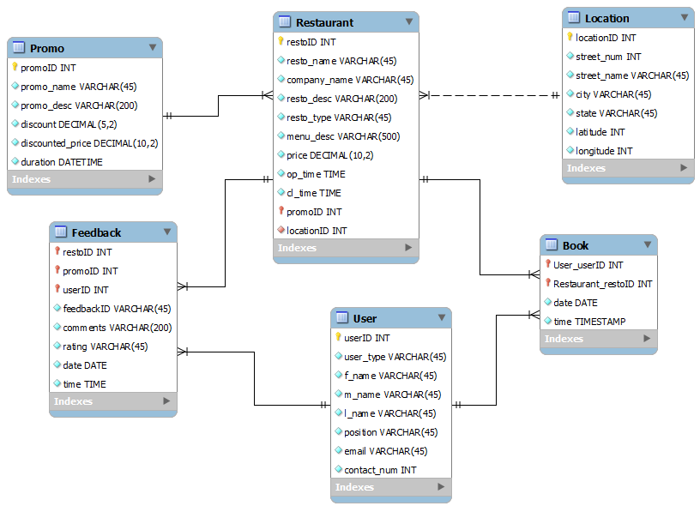

19

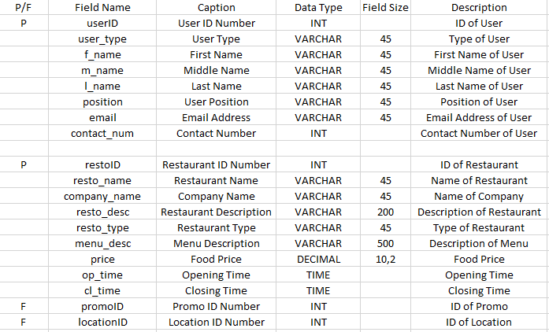**D.**       **Data Dictionary**

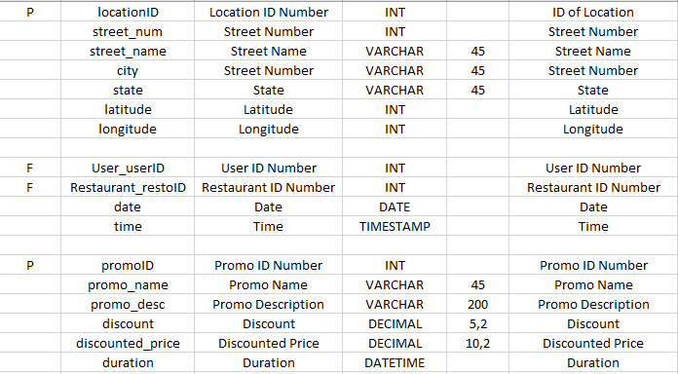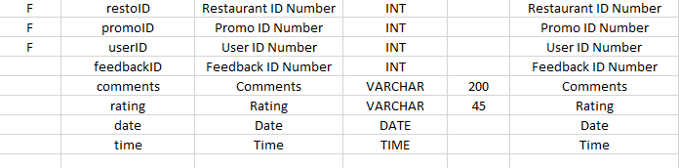

20

**E.**       **Screenshots**

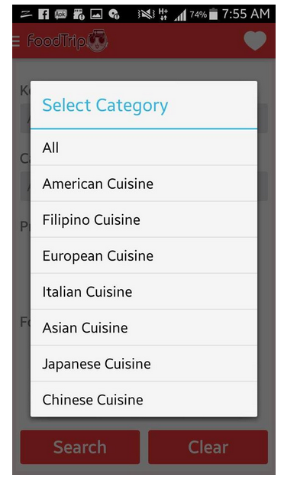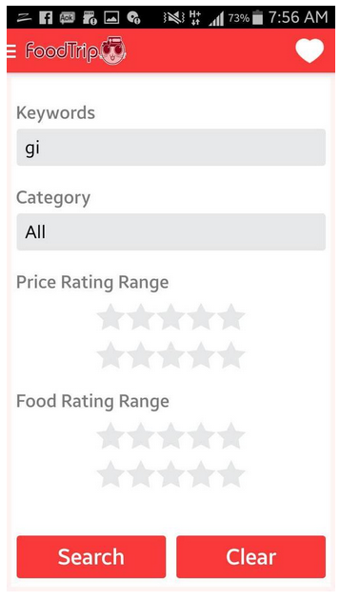

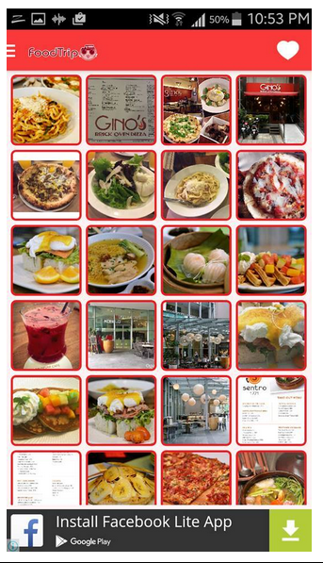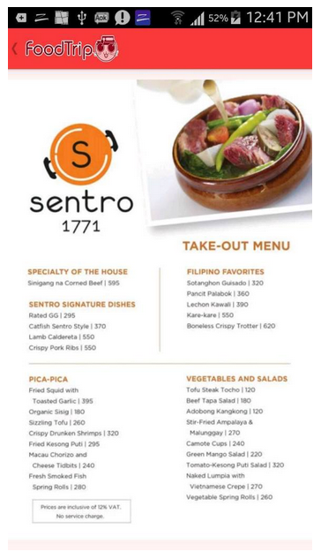

21

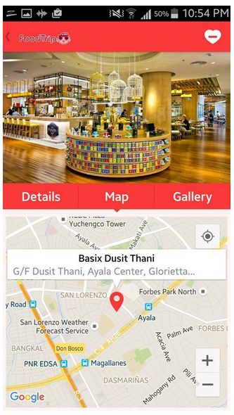

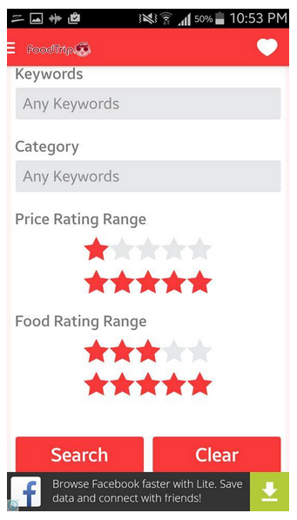

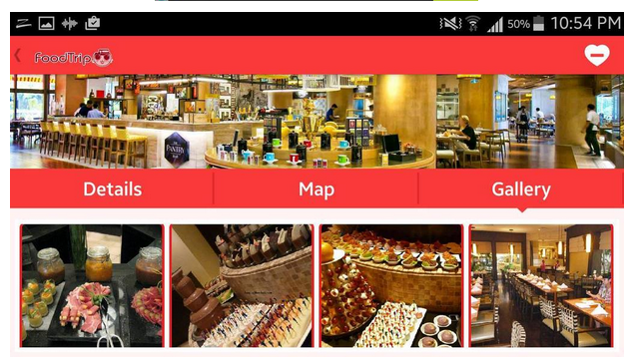

22

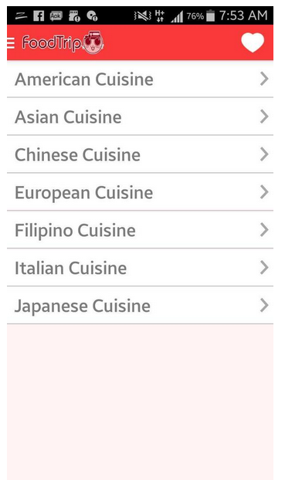

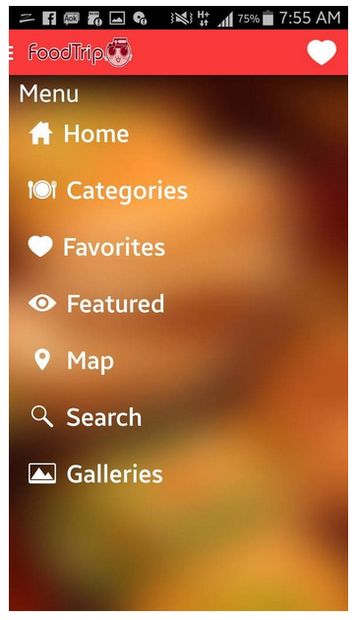

23

**F.**        **Lessons Learned**

**Jimmy Tan:**

I learned a lot about business processes to create a project successfully. The flowcharts and project plan were very useful to make the whole process clearly. I have learned many skills to create and code efficiently and to discover new things to improve our application innovatively.

**Rouzandra Zuñiga:**

I learned how to handle risk management since there are many risk factors that are happening inside the team. I am well motivated doing this project I am focused on the improvement to prevent problems that occur in this situation so I came up with all possible solutions to organize the team and its project effectively.

**Iñigo Marquez**:

I do believe that whenever a problem arises, we must act and think simultaneously to ensure that we will not be wasting time in solving that problem. Focus and determination are a must when it comes to problem solving since it is already proven that calm and focused ones produce more effective and efficient results than those of the people who are tense and cannot think straight. As for our app, I realized how consistent the requirements of the app must be in connecting to the documents procured. The outcome of this app will achieve greater results once consistency is applied.

**Jason Juarez**:

**III.**           **Appendices**

* Project Plan Template
* Foodtrip App Manual
* SRS

24

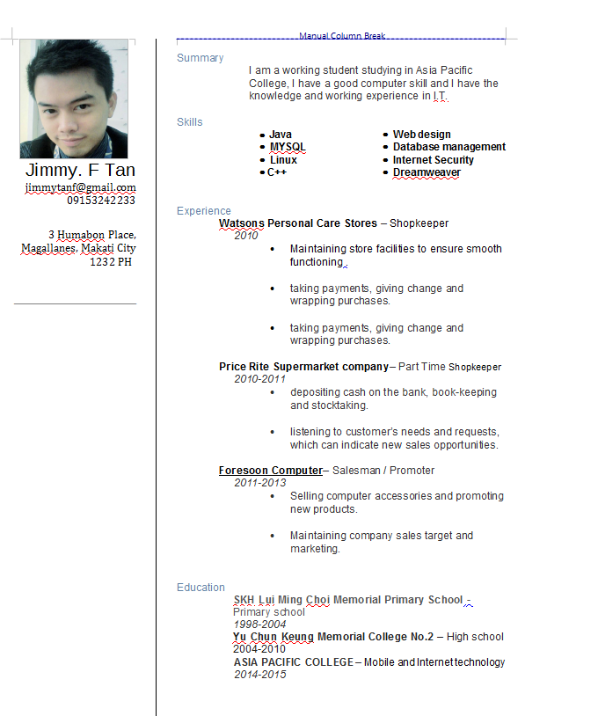**IV. Curriculum Vitae**

25

**INIGO VIRGIL U. MARQUEZ**

128 Carmelite St. Merville Park Subdivision

Paranaque City

[iumarquez@student.apc.edu.ph](mailto:iumarquez@student.apc.edu.ph)

09369026620

**Career Objective**

* To apply, exercise and improve my current skills and abilities through learning, exploring and experiencing real life situations in various environments.

**Skills**

* Oriented in Microsoft Office applications such as:
* Microsoft Office Access
* Microsoft Office Excel
* Microsoft Office Word
* Microsoft Office PowerPoint
* Capable of editing picture, files and presentation using different Microsoft Windows applications
* Proficient in Visual Basic programming language, yEd Graph Editor, DIA
* Proficient in Java programming language, HTML and PHP, JOOMLA
* Database management and design, SQL Programming

**Educational Background**

**Tertiary: Ateneo de Manila University** 2011 - 2013

**Bachelor of Science in Management Information**

**Systems**

Loyola Heights, Quezon City

**Asia Pacific College** 2013 - Present

**Bachelor of Science in Information Technology**

**Major in Mobile and Internet**

Magallanes, Makati City

26



**ROUZANDRA B. ZUNIGA**

161 Ligas 1 Bacoor Cavite City

09261576992

[rouzandra.zofficial@gmail.com](mailto:rouzandra.zofficial@gmail.com)

**EDUCATION**

Asia Pacific College, Makati City, 2013-Present

Bachelor of Science Information Technology, Major in Mobile Internet.

Westfield Science Oriented School Las Pinas City, 2009-2010

High School Diploma,April 2010

**EXTRACURRICULAR ACTIVITIES**

GUEST EVENT JUDGE (Rock Battle of The Bands) Las Pinas City April 2011

FREELANCE LEAD VOCALIST, Jellyrocks Band February 2012

Performed at Scarlet Jazz Bar, Sazi’s Bar….

CHINOY STAR KA NA GRANDFINALIST, NET25 CHINOYTV November 2013- January 2014 SM Moa Music Hall

**GUEST SINGER**

Federation of Filipino Chinese Alumni Association(Century Seafood Hotel Restaurant) February 2014

SIDE A Gig Ticket Promoting (19 East Bar & Grill) February 2014

MOR 101.9 For Life Ticket Promotion SIDE A Concert On Air ABSCBN Studio March 2014

SIDE A throwback and Giveback Concert Special Guest Ryzza Mae Dizon(Aliw Theater) April 2014

Reimos Place Grill and Bar (Dasmarinas Cavite) July 2014

OPM PAGCOR Semifinalist – A Nationwide Search for The Total OPM Performer (Casino Filipino Waterfront Hotel) May 2014

**SEMINARS ATTENDED**

Go Negosyo Seminar World Trade Center Convention 2011

**SKILLS**

**Language Skills**: Fluent in Filipino and English

**Computer Skills:** Knowledgeable in Word Processing Microsoft Office Applications and Graphic Design, Java,skilled in Database MySQL, Programming.

２７

Project Plan

FoodTrip Search Engine

Table of Contents

Table of Contents ii

Revision History ii

1. Business Requirements 1

1.0 General Information.................................................................................................1

1.1.Purpose, Scope, and Objectives………………………………………………1

1.2.System Overview………………………………………………………………..2

1.3.Contacts………………………………………………………………………….2

1.4.Project References………………………………………………………….…..3

1.5.Relationship to Other Projects…………………………………………………3

1.6.Organizational Interfaces……………………………………………………….4

1.7.Acronyms and Abbreviations…………………………………………………..5

1.8. Background 5

1.9. Business Opportunity 6

1.10.Business Objectives and Success Criteria 6

1.11.Customer or Market Needs 6

1.12.Business Risks 6

2. Vision of the Solution 7

2.1. Vision Statement 7

2.2. Major Features 7

2.3. Assumptions and Dependencies 7

3. Scope and Limitations 7

3.1. Scope of Initial Release 8

3.2. Scope of Subsequent Releases 8

3.3. Limitations and Exclusions 8

4. Business Context 8

4.1. Stakeholder Profiles 8

4.2. Project Priorities 8

4.3. Operating Environment 9

5. Gantt Chart…………………………………………………………………………10

6. Work Breakdown Structure………………………………………………………12

7. Activity List………………………………………………………………………….12

# 1.Business Requirements

We are developing an application using a database information of selected restaurants in Makati, an application that determine how search results are displayed. This application is develop to implement and market restaurants by creating an application that can show details and information about the restaurant, price list and most importantly to show its location where the user can easily access on how they can able to get to the restaurant they want.

# 1.0.General Information

## 1.1.Project Description

FoodTrip Restaurant Search Engine is an Application where you can easily access restaurant around Metro Manila explore high class restaurant's in different cuisine category and choose a restaurant you want to visit where you can view information, feedback and promotion deals.

## Purpose

FoodTrip App is a visual guide to good food and where to find it. Instead of reviewing restaurants, we can recommend great dishes and see what others recommend wherever you go.

## Scope

This project aims to provide a user friendly Web Application. An application that can be used to access high class restaurant around metro manila. The user must be a member to avail different promos and discount offered by other restaurant. The user/member may use FoodTrip App to find and review different cuisine and restaurant.

## General Objectives

The General Objective of this Application Project is to provide Diner/User's to access location and information about the restaurant around metro manila

## Specific Objectives

• To provide hassle free restaurant search around Metro Manila.

• To find desired restaurants the Diner/User wants to visit.

• To show updated restaurant menu and promotions offered by the restaurant's

## 1.2 System Overview

*Software Environment*

*Programming Languages*

* ***The application will be developed using Java, HTML5, PHP, Mobile framework***

*Specific Software*

* ***FoodTrip application uses the SQLite Database to store data and is connected to cloud server and Android Studio***

*Operating System*

* ***The application runs in Android Operating System. Android API level 19 kit Kat***

*Hardware Environment*

* ***The focus of this project is to apply the use of android phones and the internet for the user for better information about different cuisine and restaurant around metro manila.***

*Network Requirements*

* ***Internet connection – specifically DSL or Broadband internet or Wi-Fi connections***

#### Application Implementation Priorities

##### **Scheduling**

The project team will be using Agile Methodology in scheduling the project. This method will be used so that the application will be developed faster and use the remaining time to adjust the application to the client’s needs. The project time will be divided into three iterations for faster time and better communication with the client. A detailed project schedule is provided at the end of the page.

## 1.4. Project References

##### **Communication**

The project manager will set up meetings with the client for additional requirements and iteration presentations.

|  |  |  |  |  |
| --- | --- | --- | --- | --- |
| Type of communication | Communication Schedule | Typical communication mechanism | Who initiates | Recipient |
| Project Planning | Start of the Project | Face to face meetings/email | Project Manager | Project Client |
| Information Management | Sep 26, 2015 | Face to face meetings/email | Project Manager | Project Manager |
| 1st Iteration | Dec 16, 2015 | Face to face meetings/email | Project Team | Project Client |
| 2nd Iteration | Feb 29, 2016 | Face to face meetings/email Presentation | Project Team | Project Client |

##### **Risk Management**

The project team may encounter risks in the development of this project. Below is the risk register of potential risks during development.

|  |  |  |  |  |  |  |  |
| --- | --- | --- | --- | --- | --- | --- | --- |
| Rank | Risk | Description | Category | Trigger | Responsible | Potential Response | Impact |
| 1 | Start-up plan | Meeting with client, project team, and external entities | Project Planning | Absent in required meetings | Project manager | Timeframe, meetings execution could be a virtual meeting or face to face meeting | Minimal |
| 2 | Staffing/Human Resources | Project team needs an experienced staff and programmer | Project Manager | Lack of knowledge of acquired staff | Project analyst | Execute an examination or interview staff based of their qualifications | Serious |
| 3 | WBS | Scheduled restricted deliverables | Project Planning | Delayed deliverable submission | Project analyst | All the deliverables and activities should be done to avoid delays | Serious |
| 4 | controlling | Security of the system when released | Information technology department | System maintenance | Project Client | IT department will take place the potential security for security | Minimal |
| 5 | Hardware/Software | The needs of computer or laptop and other software needed | Information technology department | Insufficient funds | Project analyst | Budget allocation of hardware and software | Minimal |

##### **Training Plan**

The Mobile application requires the system to be easy to use and understandable to the majority of the user/member. The system must be designed to be interacting to the point that there will be little to no training required for the regular users. However, the administration and IT users must be trained about the back-end of the application upon implementation. Training will be provided for database and system maintenance of the application.

##### **Project Quality Assurance and Control**

To ensure that the project meet or even exceed the user’s expectation we created a quality management plan to make sure that the technology we were proposing can provide a service that the restaurant establishment needed to their day to day operations, we have the following procedures that can help us to make a quality system and achieve total client satisfaction.

-Having an accurate record of every defects and errors that we encounter on each process.

-Be familiarized in all of those defects and errors that have been occurred.

-Maximizing the time given to the team, making sure that every procedure will be done base on the time management plan.

-Use of SWOT analysis before implementing the system to lessen the chances of dissatisfaction from the clients.

-Perform an overall quality check before the implementation.

-Build a security plan for the system to make sure that the system is secured and safe for system sabotage.

##### **Procurement Planning**

Outsourcing project team members would benefit the client organization to allow the main project team to focus on its core activities and to reduce the risk of being delayed to all the submissions of deliverables.

## 1.8. Background

Food Trip Restaurant Search Engine is an Application where you can easily access restaurant around Makati explore high class restaurant's in different category and choose a restaurant you want to visit where you can view information, Food rating and price rating.

## 1.9. Business Opportunity

We are developing an application that is user friendly hassle free to the users who are looking for a place where they want to dine/eat an application that shows featured  restaurant  and allows users to access the location of the restaurant they want to visit and a GPS shows the map or the location where the restaurant is

in this project we are marketing every restaurant establishment in Makati were we show the restaurant information’s that the user or the customer will be needed in order for them to know the menu the price range of what they want to eat how much cost they will be spending when they dine in the restaurant.

## 1.10. Business Objectives and Success Criteria

in this project we are marketing every restaurant establishment in Makati were we show what is new with the restaurant information’s that the user or the customer will be needed in order for them to know the daily menu the price range of what they want to eat how much cost they will be spending when they eat in the restaurant they will visit. This application also shows the promotion of the restaurant that the user /customer can avail.

## 1.11. Customer or Market Needs

User/customer needs an application that provides all the information of the restaurant contact details and menu price list that is right at their fingertips. performance requirements the application is designed to function across a wide spectrum of mobile environments. An application designed to run on a private Wi-Fi network with free range access to the corporate network.

## 1.12. Business Risks

Market place competition we will launch our mobile application as free for a moment because there are major mobile application developers who is fully developed in the Google play. Timing issues there are risk in this situation which can cause the progress of making an application due to any reasonable reasons. User acceptance during its first launch our application will be a beta for us to estimate how the user experience will be. mobile malware Creating an environment of allowing application access to data and system resources can aggravate this risk. Advanced Threats With sophisticated cyber adversaries and attacks on networks, enterprises need to identify advanced threats in order to prepare in such threat. Compliance and Legal Issues integrating personal and professional data on one device can create difficulties in managing business risk and protecting users privacy End user Behavior.

# 

# 2. Vision of the Solution

we come up to decide to think about what idea's or plans we should be doing for our application we estimate time and cost for the features and platforms we'll be needing for this app to develop navigation we concentrate on the core features we create a data model which organizes all the information in our search engine app we create navigation using tab bar and menu's.

## 2.1.Vision Statement

Our Vision is to create a simple user friendly android app which elevates the digital profile of some restaurant establishment , we believe that our project could go a long way at establishing a user friendly oriented app. User Friendly Features

• GPS location

• Food Ratings

• Direct Call to restaurant's

• Restaurant Updates

## 2.2.Major Features

* GPS location
* Price Rating
* Food Rating
* Direct Call to restaurant's
* Restaurant Updates

## 2.3. Assumptions and Dependencies

When the project begins, there is assumptions and constraints project member’s availability, project member’s performance, project member’s skills Budget limitations, Internal process lead time, internet issues, device problems and Accuracy of the project schedule dates.

Ordering function is not included in the application we developed.

# 3.Scope and Limitations

Ordering function is not included in the application we are developing. Only the member's can receive notification of the restaurant updates, promotion updates, Scan QR Code to avail the promotions.

## 3.1. Scope of Initial Release

The Major features in the application is GPS location shows your location, including latitude & longitude and the restaurant you want to visit. Direct Call to restaurant' you can simply make a call by pressing the call tab of the restaurant.

## 3.2. Scope of Subsequent Releases

Other following functions will be included soon.

## 3.3. Limitations and Exclusion

Ordering menu restaurant features and the bookings and reservations for party or events are not included in the application project. -Business Context Use a different platform for user purposes. App should be ongoing process when creating an application it should be improve and upgrade constantly. Testing the application in other low budget phones.

# 4. Business Context

Use a different platform for user purposes. App should be ongoing process when creating an application it should be improve and upgrade constantly. Testing the application in other low budget phones.

## 4.1. Stakeholder Profiles

Restaurant Establishment are having benefits in this application we are developing because they will be able to market and advertise their restaurant establishment menu's and their current promotion and events and the some user's and customer are able to see what is the best restaurant to visit by looking at the reviews by the other people who have visited and tasted their food.

## 4.2. Project Priorities

The project will be launched as a beta version for testing and debugging purposes.

|  |  |  |  |
| --- | --- | --- | --- |
| **Dimension** | **Driver (state objective)** | **Constraint (state limits)** | **Degree of Freedom (state allowable range)** |
| Schedule | Application beta version for testing | Unexposed to real user environment | N/A |
| Features | Application functionality and features | Only member's can fully access the notification features | 70-80% of high priority features must be included in release |
| Quality | Implementing design and upgrades | N/A | 90-95% of user acceptance tests must pass for release |
| Staff | Programmer's and designers | maximum team size is 3 developers + 2 testers | N/A |
| Cost | Not yet calculated | N/A | N/A |

## 4.3 Operating Environment

<Describe the environment in which the system will be used and define the major availability, reliability, performance, and integrity requirements. This information will significantly influence the definition of the system’s architecture. Consider questions such as:

Our application is based on mobile application Java Language.

* Are the users widely distributed geographically or located close to each other? How many time zones are they in?

We will be covering this project application for Makati based restaurant only.

* When do the users in various locations need to access the system?

Everywhere as long as they download the application in the Google play store.

* Where is the data generated and used? How far apart are these locations? Does the data from multiple locations need to be combined?

Yes the data needs to be gathered in the database so that when the user search for a restaurant name they will be found.

* Are specific maximum response times known for accessing data that might be stored remotely?

-----------------------------------

* Can the users tolerate service interruptions or is continuous access to the system critical for the operation of their business?

It depends on the user but somehow if they experience bugs or something that has to be fixed in the application they will comment or report it since we are just launching it for beta version we are just under provision by its functions.

* What access security controls and data protection requirements are needed?>

Test the security quality of the applications. use application security testing as a way of protecting data. Mobile devices are often consumer owned devices that can access an organization’s internal network. enterprises are considering bring your own device.

**5. Gantt Chart**

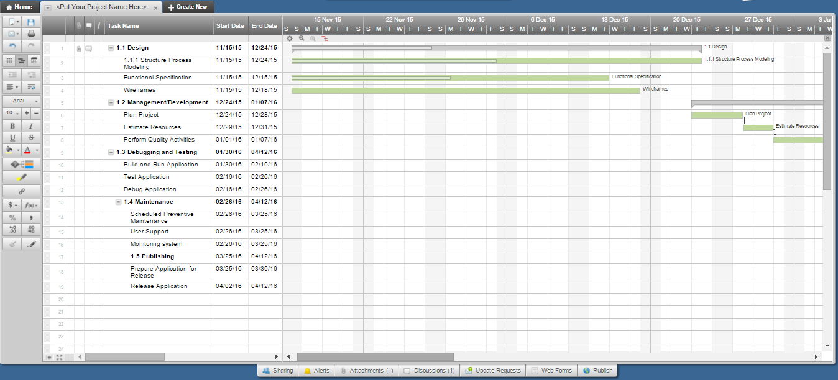

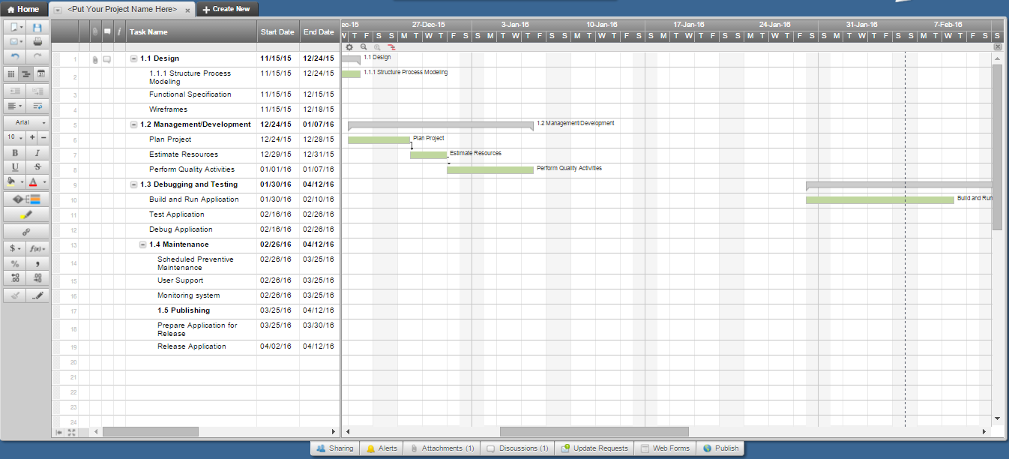

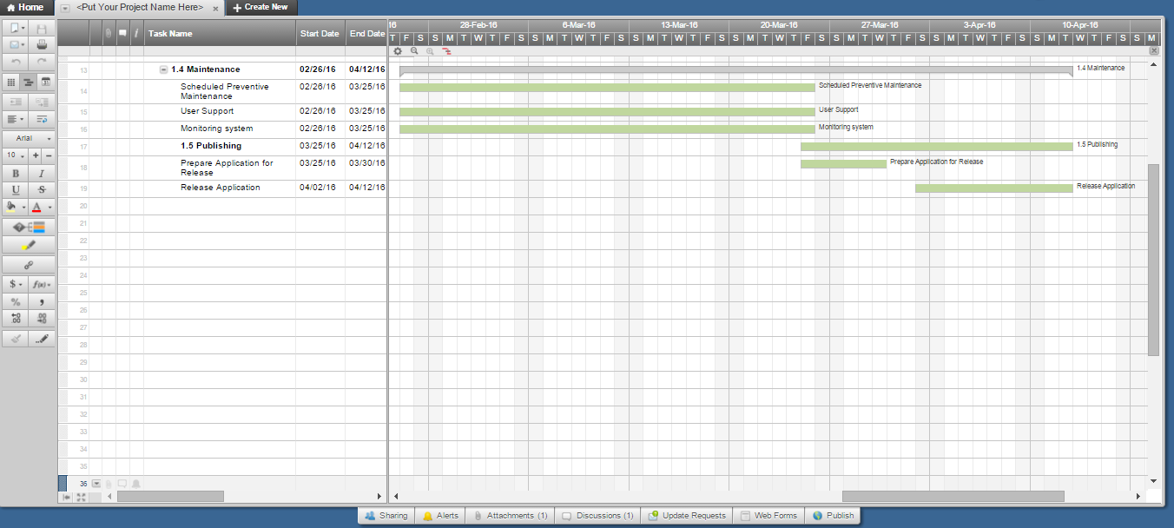

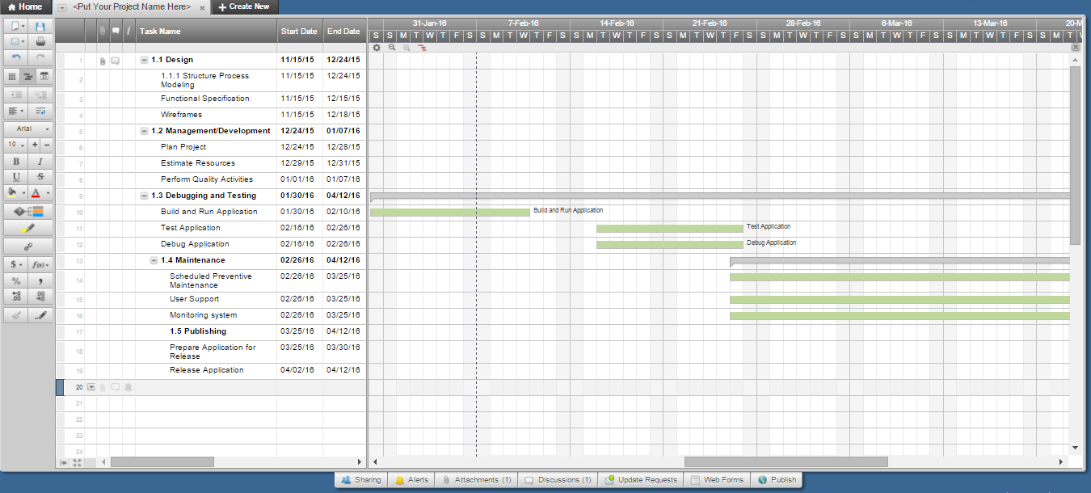

**6. Work Breakdown Structure**



**7. Activity List**

|  |  |  |  |  |  |  |
| --- | --- | --- | --- | --- | --- | --- |
| Activity # | Activity Name | Activity Name Description | # of Days | Start Date | Dependency | Milestones |
| 1 | Design | System Architecture | 35 | 11/15/15 |  | Detailed Design |
| 2 | Develop | System Development | 40 | 12/24/15 | IFS | Software Code |
| 2.1 | Code | Code - subroutine | 35 | 1/27/16 |  |  |
| 2.2 | Integrate | Integrate - subroutine | 25 | 1/27/16 |  |  |
| 3 | Testing and Debugging | Testing and debugging system | 21 | 1/30/16 |  | Completed accept test of documents |
| 4 | Maintenance | Application Upgrades | 30 | 03/26/16 |  | Monitoring |
| 4 | Publishing | Application Release | 30 | 04/2/16 |  | Final Release |

Software Requirements Specification

For

Mobile App  
Food Trip Search Engine

Version 1.0 Approved

Prepared by:

Jimmy Tan

Rouzandra Zuniga

Inigo Marquez

Jason Juarez

Asia Pacific College

4/20/16

**Table of Contents**..........................................................................................................ii-iii

Revision History ...............................................................................................................iii

1. Introduction ..................................................................................................................1

1.1 Purpose .......................................................................................................................1

1.2 Document Conventions ..............................................................................................1

1.3 Intended Audience and Reading Suggestions .............................................................1

1.4 Product Scope .............................................................................................................1

1.5 References...................................................................................................................1

2. Overall Description .......................................................................................................2

2.1 Product Perspective ...................................................................................................2

2.2 Product Functions ......................................................................................................2

2.3 User Classes and Characteristics ................................................................................3

2.4 Operating Environment..............................................................................................3

2.5 Design and Implementation Constraints ...................................................................3

2.6 User Documentation ..................................................................................................3

2.7 Assumptions and Dependencies ................................................................................4

3. External Interface Requirements .................................................................................4

3.1 User Interfaces............................................................................................................4

3.2 Hardware Interfaces ...................................................................................................5

3.3 Software Interfaces ....................................................................................................5

3.4 Communications Interfaces .......................................................................................5

4. System Features ............................................................................................ ..............5

5. Nonfunctional Requirements .......................................................................................6

ii

**1. Introduction**

FoodTrip Restaurant Search Engine is an Application where you can easily access restaurant around Metro Manila explore high class restaurant’s in different cuisine category and choose a restaurant you want to visit where you can view information, feedback and promotion deals.

**1.1 Purpose**

The purpose of this document is to present a detailed description of the FoodTrip Search Engine Mobile App. It will explain the purpose and features of the system, the interfaces of the system, what the system will do, the constraints under which it must operate. This document is intended for both the stakeholders and the developers of the system.

**1.2 Document conventions**

Not applicable

**1.3 Intended Audience and Reading Suggestions**

This document is intended to be read by the Owner of the restaurant, Documentation Head, Operation Head and the Programmers only, Stated on the document are some of the features and details about the project. This is where they can understand the value or the main concept being implied by the system.

**1.4 Product Scope**

The Major features in the application is GPS location shows your location, including latitude & longitude and the restaurant you want to visit. Direct Call to restaurant’ you can simply make a call by pressing the call tab of the restaurant.

**1.5 References**

**Zomato**

**OS:** iPhone/Android

**Description:**

Zomato is the best way to search for and discover great places to eat at or order in from. It’s a beautifully designed, easy-to-use social restaurant finder app that lets you explore all the dining options in your city. Browse through restaurant menus, pictures, and user reviews to decide where you want to eat, and use the map feature to guide you there.

1

**OpenRice**

**OS:** iPhone/Android

**Description:**

OpenRice (Chinese: 開飯喇!) is a food and restaurant guide website which currently operates in Hong Kong, Macao, China, Singapore, Indonesia, the Philippines and Thailand.Initially launched for Hong Kong (with the Traditional Chinese version only) in 1999, the English version was later introduced to accommodate the increasing demand from non-Chinese-speaking Hong Kongers and foreign residents in Hong Kong. As of July 2012, the Hong Kong website alone has approximately 40,000 recorded restaurants, 530,000 registered diners and over 572,000 ratings and comments.

**Zagat**

**OS:** iPhone/Android

**Description:**

Sometimes, less is more. Zagat gives you concise reviews of restaurants and bars, saving you the hassle of having to dig around too much. The usual filters are place along with a scoring system that rates food, decor, and service separately. Lists of expert-selected places to cover mostly any occasion, mood, or craving completes the well-rounded package, so you can spend more time eating and less time browsing.

**2. Overall Description**

FoodTrip Restaurant Search Engine is an Application where you can easily access restaurant around Makati City explore high class restaurant's in different cuisine category and choose a restaurant you want to visit where you can view information, promotion, cuisine, direct call, visit website and email.

**2.1 Product Perspective**

We come up to decide to think about what idea's or plans we should be doing for our application we estimate time and cost for the features and platforms we'll be needing for this app to develop navigation we concentrate on the core features we create a data model which organizes all the information in our search engine app we create navigation using tab bar and menu's.

**2.2 Product Functions**

**Major Features**  
• GPS location      
• Food Ratings

• Cuisine Category  
• Direct Call to restaurant's     
• Restaurant Updates

2

**2.3 User Classes and Characteristics**

Class A,B,C.

Characteristics:

Those who love to explore new restaurant and new menus.

**2.4 Operating Environment**

**Hardware Environment**

The focus of this project is to apply the use of android phones and the internet for the

user for better information about different cuisine and restaurant around metro manila.

**Hardware**

Smartphone that has at least 512mb of ram, android version 4.2 (Jelly Bean)

### Software Environment

### Programming Language

### The application will be developed using HTML5, PHP, CSS, JS and lQuery

### Mobile framework

### Specific Software

### FoodTrip application uses the SQLite Database to store data and is connected

### to cloud server

### Operating System

### The application runs in Android Operating System. Android API level 19 kitkat

### Network Requirements

### Internet connection – specifically DSL or Broadband internet or Wi-Fi

### connections

### 2.5 Design and Implementation Constraints

### Viewing of the file size of some images of the restaurants are limited

### 2.6 User Documentations

### The customers/consumers/diners in this application can view and book from the list of restaurants of their choice in the vicinity of Makati. All users have access in viewing the features, categories, galleries, menus, promotions, and locations of all the restaurants registered in the application. The manager of the restaurant has access in adding and editing the necessary information of the respective restaurant. The admin has access in editing and monitoring the web and the application.

3

### 2.7 Assumptions and Dependencies

When the project begins, there is assumptions and constraints project member’s availability, project member’s performance, project member’s skills Budget limitations, Internal process lead time, internet issues, device problems and Accuracy of the project schedule dates.

**Limitations**

Ordering function is not included in the application we are developing. Only the members can receive notification of the restaurant updates, promotion updates, Scan QR Code to avail the promotions.

### 3. External Interface Requirements

### Overview

The user interface of this restaurant booking system is a web site which can be viewed using popular web browsers. This high accessibility made it easier and more convenient for users to use the system. Users don't need to set up any additional software for the purpose of running the system. As long as an Internet connection is available, the system can be easily accessed using their mobile devices. Multi-platforms operation is also an additional advantage of this design.

One more advantage of this design is the power of the Hyper Text Markup Language (HTML). HTML provides nicer features with simple modification and configuration compared to the GUI of other languages. HTML language supports the use of other languages and technique to make dynamic objects, which can improve the vividness of the application.

### 3.1 User Interfaces

These are the fundamental features of the GUI that should be included in the websites:

### A login box comprises of an account and a password text field. Users can sign in using their Facebook account to become a member. We can provide the sign up function for long-term users so that they don't have to refill the information every time they visit the website.

4

A dynamic menu including the links to the homepage, the Food Categories, the Favorites, features, map, search button, and the Galleries.

The Category page will have the list of different restaurant with its respective image and ratings. It can be divided into many pages to ease up the navigation. The favorite page display the user restaurant marked as their favorite and a clickable map for the reservation of seats. The information page will provide additional information about the restaurant.

A slideshow or a flash of the images of the restaurant.

**3.2 Hardware Interfaces**

Describe how the software application interfaces with hardware that exists outside the scope of the system.

### 3.3 Software Interfaces

* Restaurant search feature
* Gallery feature
* Restaurant information feature
* Menu information feature
* Favorite restaurant feature
* GPS location feature

### 3.4 Communication Interfaces

* Direct call feature
* Email feature

### 4. System Features

* Restaurant search feature
* Gallery feature
* Restaurant information feature
* Menu information feature
* Favorite restaurant feature
* GPS location feature

5

### 5. Non-functional Requirements

There are requirements that are not functional in nature. Specifically, these are the constraints the system must work within.

**5.1 Compatibility**

* + 1. The website should be compatible with both Internet Explorer and Mozilla Firefox, Google Chrome and Android and Smart phones.

**5.2 User interface**

* + 1. The user interface should be as familiar as possible to users who have used other web applications and Windows desktop applications. E.g., we will follow the UI guidelines for naming menus, buttons, and dialog boxes whenever possible.

**5.3 Security**

* + 1. Access will be controlled with usernames and passwords
    2. Only administrator users will have access to administrative functions, average users will not.
    3. Database should be reasonably secured to prevent leak or loss of confidential information such as credit card details from customers.

**5.4 Performance**

* + 1. The system should be up and running 24/7.
    2. It should support at least 100 users using the online without any lag.

**5.5 Backup and Recovery**

* + 1. There should be a backup server and database to prevent service interruption or loss of data when the main server and database are down.
    2. Downtime should not last more than 30sec when switching from main server to the backup server in case of a breakdown.

**5.6 Reliability**

* + 1. The Restaurant menus and price must be updated.
    2. The location of the restaurant must be accurate for the reference of the user/diner
    3. System review will take place monthly. Any lack in performance or reliability will be addressed and improved on after each review.

**5.7 System Maintenance**

* + 1. Maintenance of the system will be conducted weekly. Maintenance will be conducted during off-peak hours e.g between 12am - 6am

### 6